AGRICULTURAL INTERVIEW
PROFILE:
I.Background of the fish pond
Business Owner: Lorenz Lirio
Fishpond name: Lorenz fishery
The Fishpond started around January 2015 and until now they operate it.

Photograpic Documentation
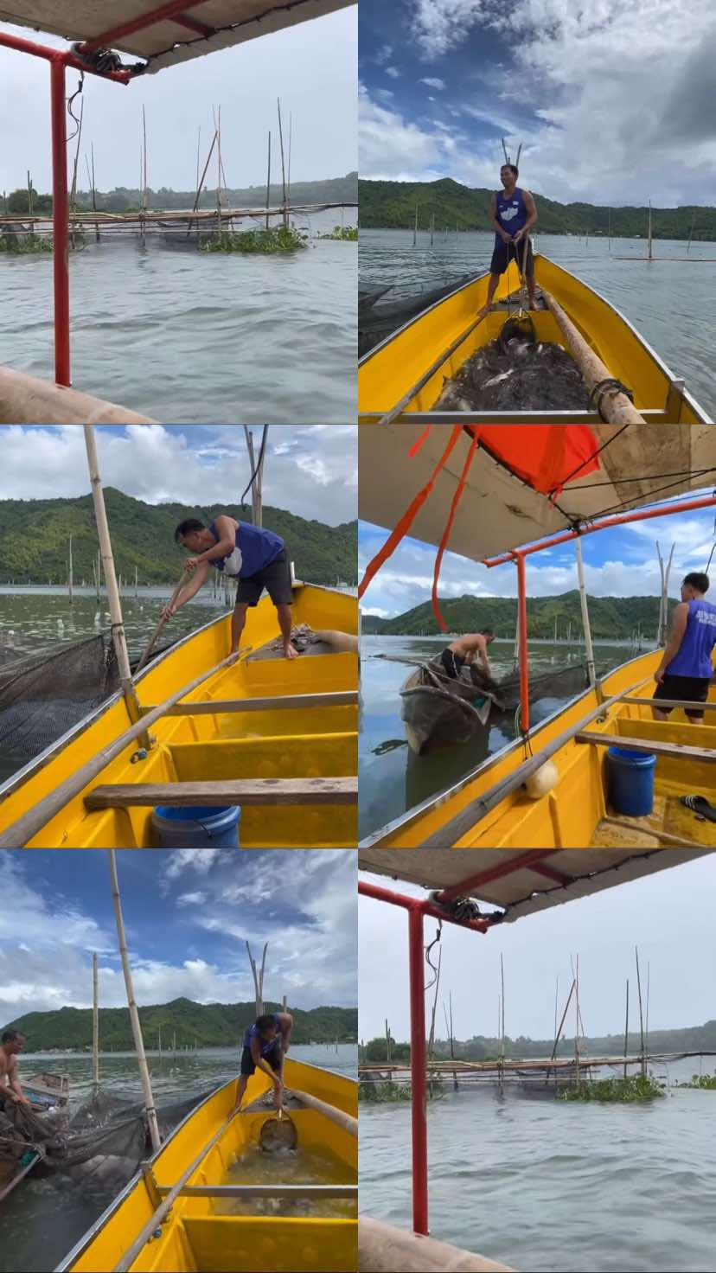
INTERVIEW TRANSCRIPT
INTERVIEW with Lorenz Lirio , owner of the fish pond

QUESTIONS:
1. What type of agricultural business do you own or manage?
-Fish pond
2. How long have you been operating your agricultural business?
-almost 3 years
3. What was the impact of COVID-19 or during the pandemic on your business?
-I lost a lot because of the lack of feed on my fish due to the prohibited exit and rescue of people in the town.
4. How many acres or hectares of fishpond do you use for your agricultural activities?
-4 hectares
5. Where do you sell your agricultural products?
-I sell it to people with large factories of different kinds of fish products.
6. What is your average annual business income?
-1.3Million
How about the pandemic days?
-Hundred thousand
7. Can you share what percentage of your annual income goes toward taxes?
-30%
8. How does the seasonality of your agricultural business affect your cash flow and income throughout the year?
-It is affected by the decrease in fish consumption and the decrease in the number of fish.
9. Is your business making enough money for day-to-day living?
-yes it is.
10. As a business owner, what do you see in your business 10 years from now?
-and I hope it will be successful and I can help a lot of people through my business.

What is the most challenging problem that you face?
-During the COVID-19 pandemic, we were unable to feed our fish and until they died.
How do you get this solution?
-After the pandemic, we have been able to recover all the fish we lost and we have increased our income.

REFLECTION:
I can say that it is necessary to work hard to overcome it, because like tatay Lorenzo he worked hard to grow his business which he also mentioned that should not be a panic so that it will grow. We must also face the challenges of life and we must overcome them so that we can continue to do what we need and we also need to help those who need them by giving them jobs to help them in their daily lives.

INTERVIEWER
Figuracion,John Glenn F.
Quiapo,Anttonete

y acres or hectares of fishpond do you use for your agricultural activities?

